3 Cross Motorcycles – Export POR Specification

Document History
Version | Status | Author | Description | Approved | Date
1.00 | Initial | NF | Initial Version |  | 11/12/2008

Distribution List
Name | Initials
Graeme Edwards | GE
Neil Frewer | NF
Nick McKeown | NM
QA Team | QA
Paul Swift | PS
Marcus Lovell | ML

Company Name & Address & Contact details
Three Cross Motorcycles Limited
6 Old Barn Farm Road
Woolsbridge Industrial Estate
Three Legged Cross
Dorset
BH21 6SP
Company Contacts | Telephone | email
Graeme Edwards |  | Graeme_Edwards@3x-motorcycles.co.uk

Introduction
Three Cross Motorcycles have a requirement to export Purchase Orders (PORs) from Exchequer. The POR export files created, will be in one of any of these 3 different formats :
1) Peugeot EDI
2) Softway (this covers Ducati, Moto Morini, MV & Cagiva)
3) Triumph

Limitations
The following limitations will apply to this bespoke software:
- This bespoke software will require Exchequer v6
- The bespoke software will only function within the core Accounts Application; it will not function for Exchequer for DOS or for any applications using the Import Modules or Toolkits to integrate with Exchequer.
- The bespoke software will be outside of the scope of the password security for Exchequer.
- This Plug-In will only support the 2 file formats described in this document. Any addition formats required now or in the future are outside the scope of this specification and development.
- This Plug-In will only allow you to export files to directories which have 30 characters or less in their directory path.
- Where a stock item has more than 1 description line, the Plug-In will only export the first line. Additional description lines will not be exported.
- The runtime licence for the Exchequer Toolkits will not be required for this bespoke software.
- The bespoke software may need modifications for future changes to Exchequer, this should be checked with Technical Support prior to installing any upgrades.
- Any functionality not described in this specification will not be implemented in the bespoke software development.
- No assumptions should be made that functionality implemented in the bespoke software will exactly duplicate Exchequer functionality, unless specifically stated in this specification.

Contact Information
Any queries about this Plug-In or requests for changes should be done through your existing point of contact. If that person is unavailable then contact can be made with the Bespoke Business Analyst at IRIS Enterprise Software Ltd on 0844 815 5590.

Plug-In Operation
A new custom button will be added to the Purchase Order Daybook named “Export POR” :
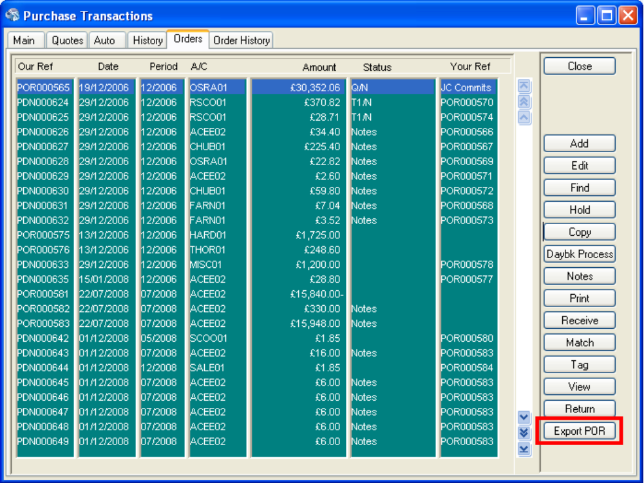
The user will highlight a POR in the list, and click on the “Export POR” button. When the button is clicked, a confirmation dialog will be displayed. For example :
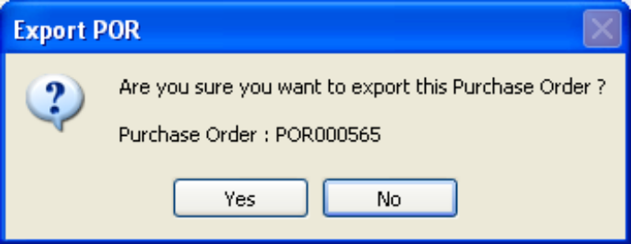
If the user click on the Yes button, then an Export file will be created for the highlighted POR (Note: if the highlighted transaction is not a POR, a message will be displayed informing the user that they can only export Purchase Orders).
The Filename of the Exported File will be constructed as follows :
PORXXXXXX_YYYYMMDD_HHMMSS.TXT
PORXXXXXX : This will be the Our Ref for the POR (e.g. POR000123)
YYYYMMDD : This is the Current System Date in the format YYYYMMDD
HHMMSS : This is the current system time in the format HHMMSS

The file format and export directory to use for the export are defined by looking up the Supplier record for the POR (in my screenshot above this would be supplier OSRA01) :
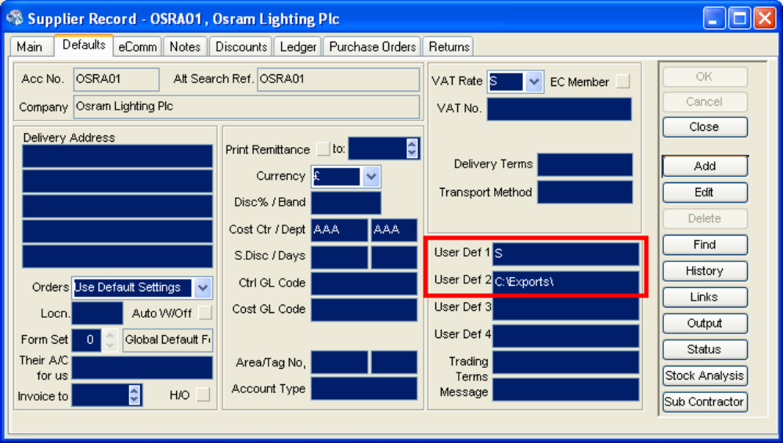
User Defined Field 1 on the supplier record will hold the Export Format for the file. Possible values are as follows :
P : This denotes that the export file format for this supplier is the Peugeot EDI format.
S : This denotes that the export file format for this supplier is the Softway format.
T : This denotes that the export file format for this supplier is the Triumph format.
In the example above the file would be exported in the Softway format.
User Defined Field 2 on the supplier record will hold the Export Directory for the file. In the example above the file would be exported to the directory C:\Exports\. Note : The User Defined Field 2 on supplier records is limited to 30 characters, so you will not be able to export to directories which have more than 30 characters in their directory path.
Note: These 2 user defined fields will be populated manually in Exchequer, by the user.

File Format - Peugeot EDI
This file format is a fixed length, plain text file. Each line in the file is either a transaction header or a transaction line. There is a header line, which is then followed by a number of transaction lines. For example a POR with 14 lines on it, will produce a text file with 15 lines - 1 line for the transaction header, then 14 lines for the transaction lines :
CDPRE8091190700033654N120080923 ...(too long to show)...*
CDPRD8091190700033654001L URGENTURGENT DHL CARRIAGE 00001000010000000000000000*
CDPRD8091190700033654002756819 CALIPER 00001000010000000000000000*
CDPRD8091190700033654003766775 MAIN HARNESS 00001000010000000000000000*
CDPRD8091190700033654004759913 LH/RH FORK TUBE 00001000010000000000000000*
CDPRD8091190700033654005768644B2HOLDER 00001000030000000000000000*
CDPRD8091190700033654006733969 MAIN ROD 00001000020000000000000000*
CDPRD8091190700033654007752409 HOSE 00001000010000000000000000*
CDPRD8091190700033654008734278E9LH SIDE PANEL 00001000020000000000000000*
CDPRD8091190700033654009754165 SEAL 00001000020000000000000000*
CDPRD8091190700033654010758148 CYLINDER HEAD 00001000010000000000000000*
CDPRD8091190700033654011758164 PISTON RING SET 00001000010000000000000000*
CDPRD8091190700033654012758159 PISTON 00001000010000000000000000*
CDPRD8091190700033654013758163 CIRCLIP 00001000020000000000000000*
CDPRD8091190700033654014L URGENTURGENT DHL CARRIAGE 00001000010000000000000000*

Peugeot EDI - Transaction Header Field Mappings
Field | Size | Pos | Compulsory | Description | Fill Value with | Toolkit Field
CODFICH | 4 | 1 | Y | type of file ( spareparts order = "CDPR") | "CDPR" | -
CODENR | 1 | 5 | Y | Second part of enter code (Headerblock = "E" ) | "E" (for header) | -
NUMCLI | 8 | 6 | Y | Customer number | Supplier code from POR (e.g. ACC001) | thAccCode
REFPIE | 8 | 14 |  | Reference of the order | "Our Ref" field for POR (e.g. POR000123) | thOurRef
FRANCO | 1 | 22 | Y | Franco port code | "N" | -
TYPCDE | 1 | 23 | Y | Type of order | "1" | -
DATSOU | 8 | 24 | Y | Desirable delivery date. Format = YYYYMMDD | The Delivery Date on the POR | thDueDate
NOMADS | 25 | 32 |  | Name of special address | Leave Blank | -
LI1ADS | 25 | 57 |  | Line 1 special address | Leave Blank | -
LI2ADS | 25 | 82 |  | Line 2 special address | Leave Blank | -
LI3ADS | 25 | 107 |  | Line 3 special address | Leave Blank | -
LI4ADS | 25 | 132 |  | Line 4 special address | Leave Blank | -
LI5ADS | 25 | 157 |  | Line 5 special address | Leave Blank | -
COPADS | 10 | 182 |  | Postal code special address | Leave Blank | -
VILADS | 25 | 192 |  | Town special address | Leave Blank | -
DATCRE | 8 | 217 | Y | Date of sending to computer site. Format = YYYYMMDD | System Date from Computer | -
HEUCRE | 6 | 225 | Y | Validation time of sending to computer site Format = HHMMSS | System Time from Computer | -
NBLIGN | 3 | 231 | Y | Line number detail which are attached to this header block | Number of lines on the transaction | thLines.thLineCount
CAFREC | 1 | 234 | Y | Character end of enter (*) | "*" | -
Peugeot EDI - Transaction Line Field Mappings
Field | Size | Pos | Compulsory | Description | Fill Value with | Toolkit Field
CODFICH | 4 | 1 | Y | type of file ( spareparts order = "CDPR") | "CDPR" | -
CODENR | 1 | 5 | Y | Second part of enter code | "D" (for Lines) | -
NUMCLI | 8 | 6 | Y | Customer number | Supplier code from POR (e.g. ACC001) | thAccCode
REFPIE | 8 | 14 |  | Reference of the order | "Our Ref" field for POR (e.g. POR000123) | thOurRef
NUMLIG | 3 | 22 | Y | Number of the line | Line number | Toolkit Line number
NUMART | 8 | 25 | Y | Number of this part | Stock Code for the line | tlStockCode
LIBART | 30 | 33 |  | Designation of part | Description of the Line | tlDescr
CONDIT | 5 | 63 | Y | Packaging | ? | ?
QTECDE | 5 | 68 | Y | Ordered quantity | Line Quantity | tlQty
FLGPRO | 1 | 73 | Y | Flag Promo | "0" | -
PRIPRO | 15 | 74 | Y | Promo Price | "0" | -
CAFREC | 1 | 89 | Y | Character end of enter (*) | "*" | -

File Format - Softway
This file format is a fixed length, plain text file. Each line in the file is either a transaction header or a transaction line. There is a header line, which is then followed by a number of transaction lines. For example a POR with 14 lines on it, will produce a text file with 15 lines - 1 line for the transaction header, then 14 lines for the transaction lines :
CDPRE8091190700033654N120080923 ...(too long to show)...*
CDPRD8091190700033654001L URGENTURGENT DHL CARRIAGE 00001000010000000000000000*
CDPRD8091190700033654002756819 CALIPER 00001000010000000000000000*
CDPRD8091190700033654003766775 MAIN HARNESS 00001000010000000000000000*
CDPRD8091190700033654004759913 LH/RH FORK TUBE 00001000010000000000000000*
CDPRD8091190700033654005768644B2HOLDER 00001000030000000000000000*
CDPRD8091190700033654006733969 MAIN ROD 00001000020000000000000000*
CDPRD8091190700033654007752409 HOSE 00001000010000000000000000*
CDPRD8091190700033654008734278E9LH SIDE PANEL 00001000020000000000000000*
CDPRD8091190700033654009754165 SEAL 00001000020000000000000000*
CDPRD8091190700033654010758148 CYLINDER HEAD 00001000010000000000000000*
CDPRD8091190700033654011758164 PISTON RING SET 00001000010000000000000000*
CDPRD8091190700033654012758159 PISTON 00001000010000000000000000*
CDPRD8091190700033654013758163 CIRCLIP 00001000020000000000000000*
CDPRD8091190700033654014L URGENTURGENT DHL CARRIAGE 00001000010000000000000000*

File format - Triumph
This file format is a fixed length, plain text file. Each line in the file is either a transaction header or a transaction line. There is a header line, which is then followed by a number of transaction lines. For example a POR with 3 lines on it, will produce a text file with 4 lines - 1 line for the transaction header, then 3 lines for the transaction lines :

0STKFree text order reference ABCD

1000011210031-T0301 000000000001

100002T3864355 000000000020

100003A9901096 000000000010

Triumph - Transaction Header Field Mappings
Field | Size | Pos | Compulsory | Description | Fill Value with | Toolkit Field
ORDER_ID | 1 | 1 | Y | Line Type (Header or Line) | "0" (denotes Header) | -
ORDER_TYPE | 3 | 2 | Y | Order Type | "STK" | -
ORDER_REF | 30 | 5 |  | Order Reference | POR Our Ref | thOurRef

Triumph - Transaction Line Field Mappings
Field | Size | Pos | Compulsory | Description | Fill Value with | Toolkit Field
ORDER_ID | 1 | 1 | Y | Line Type (Header or Line) | "1" (denotes Lines) | -
SEQ_NUM | 5 | 2 | Y | Sequence Number of the Detail Line | Line Number | Toolkit Line Number
PART_CODE | 22 | 7 | Y | Part Number | Stock Code of the POR line | tlStockCode
QUANTITY | 11 | 29 | Y | Line Quantity (no decimals) | Quantity against the POR line | tlQty

